Outdoor Catering Checklist

The checklist below is intended for use by food businesses which are attending a one or two day outdoor catering event. The checklist is intended to help you ensure that your food business operates to the highest standards of hygiene throughout the event. It provides information on how to identify any hazards in your food business and to make sure you have all the controls in place which are necessary.

This checklist is based upon the Chartered Institute of Environmental Health’s Guidelines for Outdoor Catering Events
https://www.cieh.org/media/1254/cieh-national-guidance-for-outdoor-and-mobile-catering.pdf

You should work through the checklist and ensure that you have everything in place prior to the event. Some parts of the checklist may not be applicable to you – if this is the case write N/A in the appropriate section. If you are unsure about anything contact the event organisers or Environmental Health.

The completed checklist should be sent to event organiser before the event. Officers from the Environmental Health department may attend these events and will expect you to have all the applicable elements of the checklist in place with you including appropriate documentation.

If you answer “No” to any of the questions, then there is a potential problem which will increase the risk of something going wrong. Most of these problems are routine practices, which you should already be following.

Food Business Operator:

Food Business Name:

Address:

Contact Number

Local Authority the business registered with:

Last food hygiene inspection date: Current FHRS rating:

Event attending:

Date of event:

Types of Food & preparation – please tick those that apply

Preparation, handling and cooking of high risk foods

Handling and reheating precooked high risk foods

Preparation and cooking of low risk foods

Serving open foods e.g. olives

Selling wrapped goods,

Other;………………………………………………………………………………

Food Stalls - Checklist

Issues to be Implemented | Yes | No
Food Safety Management System
Have you documented all the food safety controls you use to ensure that the food you prepare is safe to eat? (e.g. Safer Food Better Business Pack).
These food safety controls should be relevant to the transportation, storage, handling, cooking, hot holding and chilling of products which are being carried out at the event. It is not appropriate to bring a SFBB pack for your restaurant, particularly if practices at the event are different.
Do you have a supply of monitoring sheets for use at the event?
This is particularly important for temperature recording (cooking, hot-holding, chilled product storage).
Staff hygiene training records – Evidence must be supplied.
These can be photocopies.
All the records outlined above must be available for inspection at your stall on the day of the event.
Storage
Are all food storage areas under cover and protected from contamination?
Should it rain on the day of the event the whole of the stall should be protected from rain water
Are the storage areas clean and free from pests?
Do you have refrigeration?
If Yes, does it work properly?
Food Preparation and Service
Have you got enough suitable washable floor coverings for your food preparation areas?
Where the event is taking place on grass, it is not acceptable to operate without some form of washable floor covering. Generally, floor covering is desirable in those areas where handling, storage or preparation is taking place. This covering should not be a hazard in itself (i.e. slips or trips). Where the event is operating on a solid flagged area, consideration will be given to allowing trade without a floor covering – contact the Environmental Health Department for confirmation.
Are all worktables and preparation tables sealed or covered with an impervious, washable material (e.g. stainless steel, formica, washable table cloth)
(NB: This means the surface can be wiped down and cleaned on the day. A table cloth which can be washed in a washer is not suitable; you must be able to wipe it down. Disposable paper can be used in service areas where there is no food preparation).
Have you got enough preparation / worktop space for your stall to operate safely? Can cross contamination be avoided?
You must be able to have complete separation between areas used for preparation of raw products (particularly meat) and those areas for preparation and handling of ready-to –eat foods. Separate tables for these functions are essential.

Wash Hand Basins
Where open high-risk food is handled there must be good wash- hand facilities. These must include a basin or sink with a supply of hot and cold water. Ideally this should be a purpose built unit connected to a water supply and drainage facilities. Thermos flasks of hot water are NOT acceptable as they do not hold enough water. Where the source of the hot water supply is an urn the enforcement officer must be satisfied there is a safe and quick method for transferring the boiling water to the wash-hand sink and a means of mixing it with cold water in a basin with a plug. If you are unsure about this matter contact either the event organiser or Bradford MDC Environmental Health (01274 437766).
Have you got enough wash hand basins for the size of your stall / unit / number of staff? (NOTE: a bowl on its own is not acceptable as a wash hand basin. There must be an effective means of drainage into a waste water container from the wash hand basin). Where staff are split between raw and ready-to-eat products, ideally there should be separate wash hand basins for each area. If not, there should at least be means of disinfecting the wash hand basin after raw food handlers have used it.
Are the wash hand basins supplied with hot and cold water?
The water temperature must be controllable to be hand wash-safe. Wash hand basins must not share the same hot water boiler which is used for making / serving hot drinks.
Do wash hand basins have suitable waste water container?
An open bucket is not suitable. The waste water container should have a screw neck on which a lid can be screwed.
Have you got enough supplies of liquid anti-bacterial soap to last the whole event?
It is recommended that you should have at least two full bottles.
Have you got sufficient supplies of paper towels for hand drying?
There should be enough paper towels to last to the end of the event. Cloth hand towels are not recommended
NB: The use of disposable gloves at an event does not excuse businesses from hand washing. Gloves should be changed on a regular basis and hands should be washed each time gloves are changed.
Sinks
Where the catering operation is taking place over a two or three day period, equipment sinks must be provided. For one day events, equipment sinks are preferable. However, where all fruit/vegetables/salads are brought in pre-prepared (no food washing required on site), and the amount of equipment on site is limited, it is acceptable to return equipment to your food business for cleaning. However, you must be able to demonstrate throughout that used equipment will be kept separate and not used again. In these circumstances, it will not be deemed acceptable to use the wash hand basin for cleaning.

Have you got a sink(s) which is / are large enough to wash food and equipment in (including bulky items)?

Do your sinks have their own hot and cold water supply?
Wash hand basins and sinks must not share the same hot water boiler that is used for making / serving hot drinks).

Does the waste water drain into a suitable container?
Not an open bin or bucket.

Have you got separate and suitable waste water containers?
These must be clearly marked “waste water containers”.
Have you got enough fresh water containers?
These must be marked “fresh water only”.
Are your fresh water containers clean and have they got caps on them?
Fresh water containers must be disinfected using a Milton type solution and rinsed prior to use. They must also have caps on them to prevent contamination.

Cleaning
Is your stall/vehicle clean? Can it be kept clean during the event?
Do you have a cleaning schedule to ensure all areas are clean?
(Recommended – This should be relevant to the equipment being used on site and should not be the schedule for your catering kitchen, unless it is applicable to equipment being used at the event.)
Have you got an ample supply of clean cloths?
(Ideally these should be disposable one use only cloths e.g. paper towels)
Where you are using re-usable cloths, you may need to demonstrate to the inspecting officer how you ensure cloths are not used in both raw and ready-to-eat areas i.e. demonstrate separation.
Have you got an ample supply of food safe detergent, disinfectant or sanitiser and any other cleaning products that you may require to keep your business clean?
These should be readily accessible on the day but stored away from the food production area.
Are cleaning chemicals stored away from food?
They should be.
Contamination
Will your food be protected from contamination at all times?
You will need to demonstrate this on the day i.e. use of lidded containers, storing until needed etc.
Is the unit free from pests and is open food protected from flying insects?
Storage and preparation areas should be free from pests. Flying insects will be a potential problem. Minimise the amount of food on display, cover pans with lids.

Food Waste
Have you got proper bins with lids for food and other waste?
Bins should be lined with a bin bag.
Do you know where the waste collection point/s is/are on the site?
You will need to determine whether you are responsible for the removal of waste or whether it is the event organiser who will provide waste disposal services.
Do you have arrangements / know the arrangements for the collection and disposal of waste oil (if applicable to you)?

Staff
Are all your food handlers trained, supervised and given instruction to ensure food safety?
Officers will questions staff and observe practices on the day. Staff should be knowledgeable about food safety and demonstrate good food handling practices.
Have your staff been given a supply of clean personal protective clothing to wear at the event?
Staff must be provided with protective over-clothing. It is not acceptable for staff to handle/serve food in outdoor/everyday clothing. The food must be protected.
Are your staff aware that they should not handle food if they are suffering from certain illnesses? Are they aware of the 48 hour rule?
It is important that they know they shouldn’t be working if they have sickness and diarrhoea and they should not work until they have been free of symptoms for 48 hours.
Do you have a first aid box with brightly coloured plasters?
(Usually blue – skin tone is not acceptable).
Safe Food Practices During the Event
Storage
Are raw and cooked foods adequately separated during storage?
They must be.
Are high-risk cold foods (e.g. cooked rice) stored under refrigeration below 8ºC?
Do you have enough fridges for all your food?
It is essential you supply sufficient fridges for all your chilled food particularly if you are dealing with raw meats and ready-to-eat foods.
Do you have procedures in place to ensure that the temperatures of the fridges are checked on a regular basis?
The temperature should be below 8ºC and this should be recorded.
Are you using freezers?
If yes, specify chest freezer or trailer freezer.
Will the freezers be switched on during the whole of the event
They must be kept on?
Preparation
Do staff know when they should be washing their hands?
Before preparing food, after handling raw food/rubbish/taking a break/smoking/visiting the toilet.
Do you use separate chopping boards for raw and cooked foods?
You must do. These must be clearly identifiable, ideally they should be colour coded.
Cooking
Do you have a working digital probe thermometer?
You must have one on site and it must be in good, clean condition and be working.
Are sanitising probe wipes available to clean and disinfect the thermometer?
Is raw and frozen meat/poultry thoroughly defrosted before cooking?
You must be able to explain to the officer how and where this is done.
Is raw meat/poultry cooked until it is piping hot (>75 ºC)?
Do you check the temperature of cooked foods?
You should be making periodic checks of hot food and recording those temperatures.
Are cooked and part cooked foods separated during cooking?
You must be able to demonstrate to the officer how you do this e.g. on your griddle etc.
Re-heating Food
Is all high risk food re-heated above 75 ºC?
It should be and you should be recording periodic temperature checks.
Do you re-heat food more than once?
If you re-heat food more than once you MUST change your practices. Food should never be re-heated more than once.
After Cooking and Re-heating: Serving and Displaying Hot Food
Is food cooked and served straight away?
i.e. is food cooked to order?
If no, is it kept at or above 63 ºC until it is served?
If the temperature drops below 63 ºC, the food must be sold within 2 hours.
Have you got checks in place to make sure you meet with the requirement?
You must have some checks. If food does drop below 63 ºC, you must be able to demonstrate to an inspector that it has not been on display any longer than 2 hours at this temperature. You will need to keep a log of times and temperatures.
Cleaning
Is a “clean as you go” procedure in place for the event?
All members of staff should be cleaning up after themselves before they move on to the next task.
Are you using clean cloths and a food safe disinfectant / sanitiser to clean food contact surfaces?
It is preferable that you use disposable cloths (e.g. paper towels). Where a disinfectant / sanitiser is in use, staff should be instructed in its correct use and ensure any contact times are followed. Disinfectants which smell strongly of pine or lemon or other perfumes, are not suitable – they must be food grade.
Ice
Will you be using ice at the event? What for?
If yes, is it brought in ready-made?
If no, do you make it with bottled water?
You should not be using tankered water for making ice.
Gas & Electricity safety
Understand the regulations and your responsibilities
Get to know the regulations that you need to comply with and make sure you know what your responsibilities are.
Please have a look at the Health & Safety at Work Act (1974), the GSIUR (Gas Safety (Installation and Use) Regulations 1998) the NCASS Guidance for the Installation of LPG and PLG fired equipment in Catering Trailers, Converted Vehicles, Portable Kitchens, Carts, Trolleys and Bikes or the NCASS Guidance for the Installation of LPG and LPG fired Equipment in Tented Structures, Stalls and Gazaebos and Code of Practice 24, sections 2 and 3. (Which Code of Practice is this?)
(The appendices at the back of the each NCASS guidance document contain example gas safety inspection certificates and an enforcement officer checklist).
Only use equipment that’s suitable for commercial catering
Never use camping equipment in a commercial catering business.
Make sure all your LPG equipment is CE marked
To be legally compliant, all LPG commercial catering equipment must be CE-marked (Gas Appliance (Safety Regulations) 1995). This is to ensure maximum safety and minimise risks to everyone near your unit.
Flame Failure Device
HSE’s Safe use of LPG insists the need to have flame failure devices on all LPG equipment. Should the flame go out, the gas supply will automatically cut out.
Risk assessments
Keep your fire safety and health and safety risk assessments up to date and ensure you follow them to the letter every time you trade.
Storage of LPG cylinders
Do not keep LPG cylinders in close proximity to naked flames. Store them at least 1m away from the stall/tented structure on even ground away from public access. Cylinders larger than 13kg must be secured to prevent them falling over.
LPG cylinders in trailer compartments/vehicles must be ventilated at low and high levels.
Fire precautions
6 litre foam/CO2 extinguisher and 6 litre water fire extinguishers to be provided as per Section 7 of the NCASS guidance. Staff should be trained in the use of extinguishers. (If there are other fire precautions on site you may not wish to include this section/this section may not be applicable.)
Worm drive hose clips (jubilee clips)
Jubilee clips should not be used to secure the hoses as they can bite into the hose and cause damage. There is no way of knowing if the clips have been over-tightened or are providing an effective seal.
Secure hoses
Suitable factory-fitted swaged or crimped connectors must be used to secure each end of low pressure hoses.
Gas safety inspection certificate
The law requires that you have your LPG appliances checked and maintained by a qualified Gas Safe Register engineer at least once a year. (The duty to have appliances checked every 12 months under Reg 36 GSIUR 1998 only applies to landlords. Reg 35 requires gas appliances to be maintained in a safe condition. You may wish to delete ‘at least once a year’ or retain it as a condition of trading at Saltaire Festival. Both of the NCASS documents refer to a minimum annual gas safety check). Obtain a certificate of inspection for all LPG appliances that you use on site.
Has your refrigeration and any other electrical units you may use at the event been PAT tested?
All electrical equipment used on site must undergo PAT testing, unless it is under 12 months old, and you must have a certificate to prove it has been PAT tested.

Food Poisoning is preventable – by following the checklist and ensuring that everything is in place on the day – you can help to avoid it.

1. Stall holders need to be clear from the outset what foods they are going to produce at the event. Do not keep changing plans and do not over-complicate things by producing lots of different foods.

2. Keep food preparation and handling to a minimum on the day. The more food preparation you can do prior to the event, the better.

3. Try to minimise the amount of raw food that is handled on site.

4. If you are bringing pre-cooked bulk foods to your stall, you must make sure that you have adequate storage facilities to keep these foods safe.

5. Bulk foods should be cooked safely, cooled down quickly (ideally within 90 minutes of cooking) and then kept cold below 8ºC right up until the point of use.

6. You must keep records to show that these foods have been cooked to a safe temperature, cooled quickly and then kept at the required chill temperature.

7. It is not recommended that hot food is transported to the event site. Hot food must be maintained at a temperature of 63 ºC or above. In practice this is very difficult to maintain when transporting food from a catering kitchen to an event venue. It is preferable that food be cooked, chilled down and then re-heated on site.

Outside Catering Gas Safety Checks Opening Checklist

Gas Cylinders:
Are your gas cylinders stored in a well-ventilated area Y/N outside of the marquee/tent?

If No, unless you have a single butane cylinder you must move them to the outside area.

Are your cylinders upright on a firm, level hard standing? Y/N Are the cylinders located away from entrances/exits & circulation areas? Y/N Are the cylinders away from any heat source? Y/N
Are the cylinders kept clear from rubbish/other debris? Y/N Are the cylinders at least 2 m away from drains/drainage covers? Y/N Are oil drums/other flammable materials stored away from the cylinders? Y/N

Hoses:
Are the flexible hoses labelled with the BS3212/BSEN1763? Y/N
Are the flexible hoses less than 2 years old? Y/N
Are the flexible hoses in good condition? Y/N
Are the hose clips suitable and in good condition? Y/N
Is the regulator labelled with BS3016 or BSEN12864? Y/N Is the hose length from the regulator to the appliance no more than 1m? Y/N Have you checked the hose connections with soapy liquid? Y/N

Management:
Have you provided training on gas safety to all your employees? Y/N Do you ensure no smoking near the cylinders? Y/N
Do you have emergency procedures in place? Y/N
Do you have a copy of your emergency procedures onsite? Y/N
Can emergency services gain access to the cylinders? Y/N
Have you displayed appropriate signage? Y/N

Closing Checklist
Have you turned off the gas to all your appliances? Y/N Are your gas bottles stored safely and cannot be tampered with? Y/N Have you removed all empty cylinders and stored them safely? Y/N Have you removed all cardboard and rubbish (incl. oil) from your unit? Y/N

If you answer No to any of these questions then you need to take action.
Please read the rest of the guidance note for assistance.

Safe Method: Gas Safety in Outside Catering
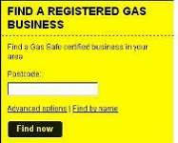

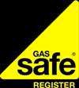

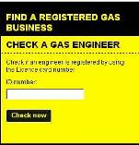

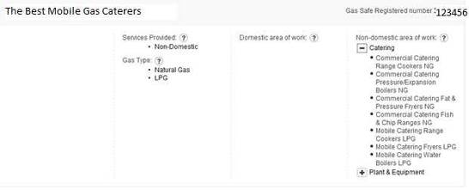

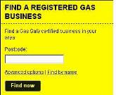

LPG is flammable. It must be stored away from sources of ignition in a well

ventilated area. Abuse of LPG is highly dangerous. Treat LPG with Respect—it can

become explosive.

Safety Point Why? What do you do? Gas Safety Requirements

Gas equipment and services must only be installed,
and repaired by a
Gas Safe registered installer.

Engineers must be suitably qualified to work on Mobile Catering Equipment.
Check if your engineer is registered on www.gassaferegister.co.uk or contact 0800 4085500.
You can search using their ID number or their business name or postcode.
If the equipment or services are not correctly fitted gas escapes or water leaks could occur or the appliance could give out poisonous fumes into the workplace.
When was your gas equipment pipework installed?

Who installed your equipment?

Did you check if your engineer was registered with Gas Safe, to work on mobile catering equipment?

Yes No

Gas appliances, flues, pipework and safety devices should be inspected regularly in accordance with the manufacturer’s recommendation.
The Gas Regulations require all gas appliances, flues, pipework and safety devices to be maintained in a safe condition.

They should be inspected by a competent person regularly. You must follow the manufacturer’s recommendations or speak to your gas safe engineer.
Note in the Maintenance log or in your diary when your gas equipment and services were last serviced.

Note down who carried out your gas service.

If you used a gas engineer, keep a copy of your certificate with your records.

If you used a Gas engineer did you check that they were registered with Gas Safe to work on Mobile catering equipment?

Yes No

Safety Point | Why? | What do you do?
Positioning of Cylinders
Ensure LPG cylinders are placed at least 2 metres away from drains or drainage covers.  Never store the cylinders near to a heat source or in direct sunlight. Never store cylinders next to flammable substances such as cooking oil.  Never smoke near the gas bottles or any other source of ignition.  Ensure the Emergency services can gain easy access to the cylinders in the case of an emergency. | LPG vapour is denser than air and any leaks could flow along the ground into the drains and may be ignited at a considerable distance from the source of leakage.  Heat will cause the pressure inside the cylinder to build up to an unsafe level.  Gas bottles are explosive and highly flammable.  To stop a fire or gas leak as quickly as possible. | Where do you store your cylinders?
Cylinders should be sited at least 1 metre, measured horizontally, from any ventilation openings or accessible compartments of any adjacent permanent or temporary buildings or structures, or other possible sources of ignition.  Propane cylinders should be sited in the open air and not inside marquees, tents or other enclosures.  Single Butane cylinders may be located inside marquee, tents or other enclosures provide that they:  - Only supply a single appliance  - Are positioned next to the appliance but not subjected to heat from the appliance  - Are suitably placed to allow easy access to the cylinder valve  - Are kept upright on a firm level hard standing  - Are kept away from storage of rubbish, cardboard or other flammable material. | To provide adequate ventilation and prevent the cylinders from being knocked over. | What type of gas cylinders do you use?  Propane  Butane  Do you store the cylinders: inside the tent/marquee or outside  ?  How many cylinders do you have at each event?
Cylinders should be positioned in the upright position on firm, level hard standing. You must ensure the cylinders cannot topple over or be subject to vandalism. You should consider securing the cylinders.  If a suitable rigid structure is not available then you may use a temporary post driven into the ground to provide support.  Cylinders should be located away from entrances/ exits and circulation areas.  The number of cylinders kept should be the minimum necessary for the type and number of appliances served. Any reserve cylinders in stock should be on a 1 for 1 replacement basis. | To prevent gas leaks from damaged pipework or tanks. | How do you ensure your cylinders are stored correctly at every event?  How do you store the reserve and empty cylinders?

Safety Point Why? What do you do? Safe connection

Pressure regulators, automatic change over devices etc. should be located as close as practicable to the cylinder. Flexible connections should be as short as practicable whilst being long enough to provide the flexibility required without excessive strain on the hose or the end fittings.

Ensure you use the correct regulator for the type of gas.

Always follow the instructions supplied when connecting the pressure regulator to the cylinder and do not open the cylinder valve or regulator tap until the pressure regulator is securely attached.

Tools must never be used to turn cylinder valves on or off.

Never smoke or use your mobile phone when connecting the equipment.

Look at the washer of the pressure regulator or valve before connecting each new cylinder. If the rubber looks worn or damaged replace it or contact your supplier.

When the appliance is not in use, turn off the regulator tap.

Signs should be displayed stating ‘EXTREMELY FLAMMABLE LPG. NO SMOKING. NO NAKED LIGHTS’.
To minimise risk of explosion from gas.

Pressure regulators are designed specifically for either propane or butane to ensure they regulate the pressure when temperatures change.

To ensure the gas is supplied at the correct pressure.

They may damage the values and cause a gas leak.

Any spark could ignite the gas and case a fire or explosion.

To minimise gas escape.

To prevent unnecessary release of gas and potential build-up of Carbon Monoxide.
To provide safety advice to employees and members of the public.
Describe what you do:

What written instructions are provided for your staff?

What signage do you display?

The storage of rubbish, cardboard or other flammable material should not be near to the LPG cylinders. A physical barrier protecting the space around the cylinders is recommended.
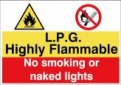

To prevent a fire from occurring.
Do you keep the area surrounding the cylinder free from rubbish, cardboard and other flammable materials?
Yes No

Safety Point Why? What do you do?

Hoses
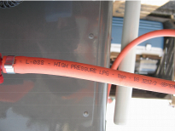

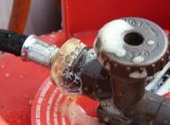

The flexible hoses must be manufactured to BS3212 type 2. This can be found written on the pipework.

Hoses must be replaced as soon as they show signs of wear, aging, damage, weathering or cracks.

Hoses should be replaced every 2 years or when signs of wear and damage is identified.

Hoses that carry gas from cylinders to regulators must have factory swaged connections and cannot be used with just homemade crimps?

High pressure hoses type 2 must be used before the regulator. All pipework is labelled detailing the pressure, the British Standard (BS) and the date of manufacturer.
The connection between the gas cylinder and the regulator should not be any longer than 1m.

Where an appliance is intended to be connected to a cylinder by means of flexible hose, the hose should not exceed 1m in length.

Hoses should be protected from mechanical damage and excessive heat. They should not be routed under temporary flooring.

Where an appliance is connected to a cylinder via a flexible hose, all joints should be leak tested by brushing with soap solution or leak detection fluid prior to use. The connection between the cylinder and regulator should also be checked.

Each time cylinder connections are broken and remade, the joints should be leak tested.

To prevent gas leaks.

Damaged hoses will cause gas to escape and could cause a fire or explosion.

To prevent pipe damage and likelihood of leaks. Longer pipework may also cause tripping hazards.

To prevent heat damage and gas leaks.

To detect leaks. If the solution bubbles there is a leak.

To ensure the connection is not allowing gas to escape.

What information is on your hoses?

How often do you replace your hoses?

What is the length of your pipework connection between the gas cylinder and the regulator?

What is the length of your flexible hose between the cylinder and the appliance?

Do any of your hoses require to be protected from heat e.g. use of braided or armoured hoses?

Yes No ?

How do you test for leaks?

When do you test for leaks?

Safety Point | Why? | What do you do?
Appliances
You must treat empty cylinders like full ones and ensure they are stored safely. | Empty cylinders may still contain LPG vapour and is potentially dangerous. | How do you store your empty cylinders?
Appliances should be fixed securely on a firm non-combustible heat insulating base.  Gas fired catering appliances should be positioned at a sufficient distance away from flammable materials such as tent canvas or screens.  Position your equipment to avoid tampering by unauthorised persons. | To avoid accidental ignition. | Do you ensure all catering appliances are positioned away from flammable materials at all times?  Yes No
Ventilation
If appliances are not in the open air  e.g. in tents, marquees, huts then it is essential to ensure sufficient fixed ventilation is provided.  The front opening of a marquee is not deemed to be adequate ventilation.  Separate fixed grills must be provided to the walls of the tent/ marquee or structure. | To prevent build-up of carbon monoxide which is a poisonous gas. | How do you ensure adequate ventilation is provided: -
Emergency Procedures
You must have notices displayed on what to do in an emergency e,g. gas leaks and fires.  A safety notice on how to connect and disconnect the LPG bottles should be displayed next to the gas bottle storage.  Suitable signage should be displayed on the bottle with ‘Caution LPG and Highly flammable’. | To ensure everyone knows what to do in an emergency.  To remind staff on how to carry out this safely. | What notices do you display?

Pipework examples

Hoses that carry gas from cylinders to regulators must have factory swaged connections. Jubilee clips can be used from the regulator to the appliance. However, the clips must be smooth inside and not worm drive jubilee clips with teeth as these will make holes in the pipe and may release gas. Screw driven fastenings must be avoided as these can be over tightened and damage the hosing.

Regulator must have Year of Manufacturer, BS3212/

Factory swaged connection
Crimp Clip

Over tightened
factory swaged connection

There is no jubilee clip to attach the flexible hose to the regulator, causing gas to escape.

Pipework must be in a good condition. Check the pipework each time you use it and replace it immediately if it is damaged. Braided or armoured pipes should be used if they are subjected to temperatures over 50oC.

The braided hose is frayed.

The pipe is badly cracked at the join and is likely to leak gas.
Replace immediately.

The flexible hose connection to the double ring burner has no jubilee clip. The gas reacted with the heat from the flame and caused the flexible hose to burn.

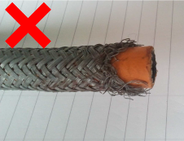

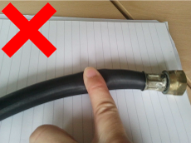

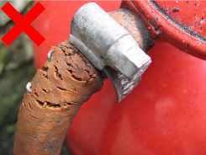

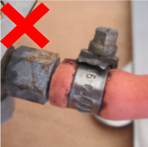

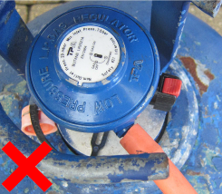

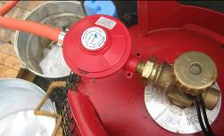

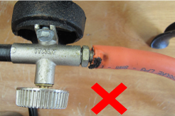

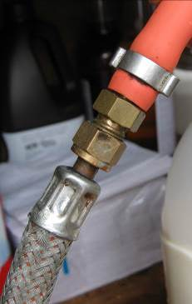

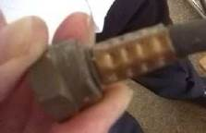

The pipe is leaking gas - the piping can be compressed and has widened. It should be firm and the same width throughout.

Pipework examples
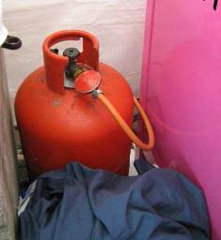

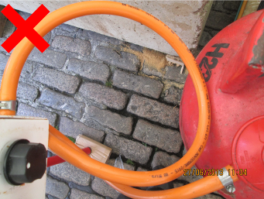

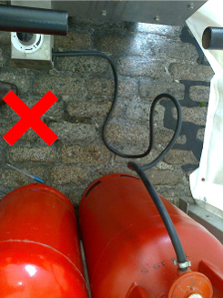

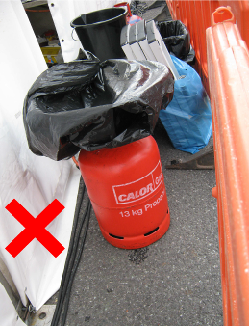

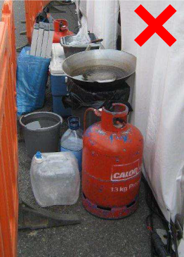

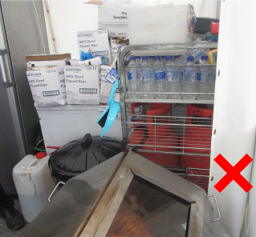

Hoses must not be coiled and should be at least 1m away from any source of ignition.

Propane Gas bottles must be placed in the open air. The photo below shows the gas bottles crammed in a tent next to a chest freezer and a hog roast cooker.
Water bottles and other items had been placed on top of the gas bottles.

Length of hose too long

The length of the flexible hose should not be more than 1m from the regulator the appliance.

Do not store equipment or rubbish on top of, or near to, gas cylinders.

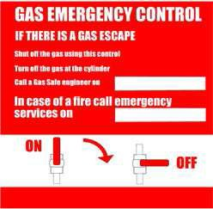

Safety Point Why? What do you do?
Emergency Procedures
A documented procedure is recommended explaining what to do in an emergency with useful contact telephone numbers.  A notice should be displayed for your staff.  Where a bulk propane supply or more than 2 cylinders with a maniford or automatic changeover device are used, a separate emergency shut off should be provided at the inlet to the common supply.  All catering staff who use the gas equipment should be trained in its proper use and how to carry out visual checks for obvious faults.  DO NOT use a naked flame when looking for gas leaks.  A 1 x 5kg dry powder fire extinguisher should be available for each 2 x cylinders used. Place your extinguishers in a conspicuous place.  In the event of a fire:  - Raise the alarm immediately and call the Fire Brigade advising them of the presence of LPG.  - Shut all valves on cylinders  - Keep cylinders cool by using water spray if possible. | To ensure all staff know what to do in an emergency and so they all know how to turn off the gas supply.  The notice will remind staff what to do in an emergency.  To ensure they can spot any signs of damage and to activate your emergency procedures.  Staff should check each day for:  - Visual check of the cylinders, pipework, appliances, flues and vents.  - Is there a smell of gas—LPG has a distinctive smell.  - Frosting or shimmering may indicate a gas leak.  - Check the connections for leaks using a soapy water solution (bubbles can be seen if joints/hose have leaks)  - Is there any damaged pipework or connections?  - Are appliances securely fastened to the vehicle  - Are the appliances turned off whilst the vehicle is in motion and the gas supply turned off at the cylinder.  - Is the flame quality good? | What is your emergency procedure in the event of a gas leak?  What notices do you display?  What training do you provide to your staff?

Plan of your event layout

Please draw the location of all of your equipment including the position of the entrance/exit and any additional air inlets. Please show the location of your gas bottles and fire extinguishers.
Note the position of your change over valves and Emergency Control if applicable.

Maintenance Log
Date of Service | Who carried out the  service? | If you used a gas engineer,  did you check that they were registered with Gas Safe to work on  Mobile Catering Equipment? | Did you receive a  gas safety certificate?  (If yes, ensure a copy is kept with this record)

