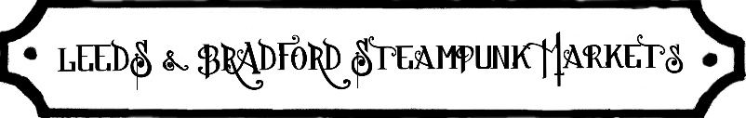
TRADER FORM
All bookings are subject to the LSM Traders terms and conditions which are on the website and must be read in full.
http://www.leedssteampunkmarket.co.uk/trader-information.php

Company Name
Address
Landline No |  | Mobile No
Email Address
2nd email
Contact Name
Please give a detailed description of your products/services.
It is important to give us detailed information as we like to offer our customers a variety of products and not over saturate any product category, therefore you may only be permitted to sell the products you list here and may be asked to remove any items not listed from sale at the event. Please also attach a selection of high-res photos to show examples of your products.
Any health problems we need to know about? **
Does your stall require power?
Are you bringing your own table or rail/s? State qty & size *
Which date/dates?
Which day/s? Please specify if more than one as we do 5 a year*
*Delete as appropriate
 | 30th June – 1st July |  | Sat only / Sun only / both days / tbc
 | 29th – 30th September |  | Sat only / Sun only / both days / tbc
 | 1st – 2nd December |  | Sat only / Sun only / both days / tbc
 | Dates in 2019 yet to be confirmed..
If you book for several events.. | You will be sent information as a reminder on each event - please reply to confirm you’re still able to do it. Invoice will be sent at the same time.  *I’d like to pay £20 deposit on each to confirm my other pitches now.  *Please delete as appropriate and add any further notes or comments in the section below
***** Pitch size single/double etc
PLI attached? ***
Website/Online Shop Address
Facebook page Address
Facebook profile
Any other notes
Signed
Date

On receipt of this form, an invoice will be sent for the next event we have coming up.
We are unable to reserve unpaid trading spaces. A deposit confirms your pitch but you must complete the full payment promptly. Any delay means it could be filled by someone else if the event fills up.
Cut off dates are usually 1 week before the event and a month before for the Prompt Payment Discount.
Full payment is usually taken one event at a time but there is the option to pay deposit on forthcoming events. If you want to pay your full pitch fee further in advance please email.
No pitch is confirmed without an email from LSM to confirm payment received.
Thank you for your understanding.

*Really helpful if you do have your own table as venues may not supply enough for all traders. Only exception to this is at Bradford Industrial - they have none whatsoever so we have to pay to hire them all in. It makes it far easier for us that way so you may not need to bring yours. Please advise if you need to bring your own if it is set up to hold a framework or whatever. On all events do advise if yours is not a standard 2' x 6’ (some are 2’6”)'.

**In regards to health, we don't just mean mobility problems - some of our venues have working machinery where it may affect things like asthma.

***The only reason for replying "no" to previous question is because you've not got it yet and getting it started closer to the date of the event as new trader.

****Send either the original downloaded document the insurers sent you. It will be called Statement Of Insurance or Certificate Of Insurance. If not scan it in and send as an attachment. If you are taking a photo please ensure you have a large size/resolution so that I can zoom in on it and read it! Then attach it to the email. Most insurance companies will allow you to take out PLI (or renew it) and for it to be dated in advance commencing from the actual trading date to save you paying for dead time. If you are with A&N I know their PLI runs for a year so just send me proof of your membership.

*****Please check pitch details on the website for the relevant event in regards to how pitches are laid out to see what size pitch you need. Some venues supply metric sized tables which give the same footprint as a 6’ x 2’.

